Heritage Corridors
of Bath,
An Ohio Scenic Byway

2025
Bath Township
Corridor Management Plan (CMP)
Ohio Department of Transportation

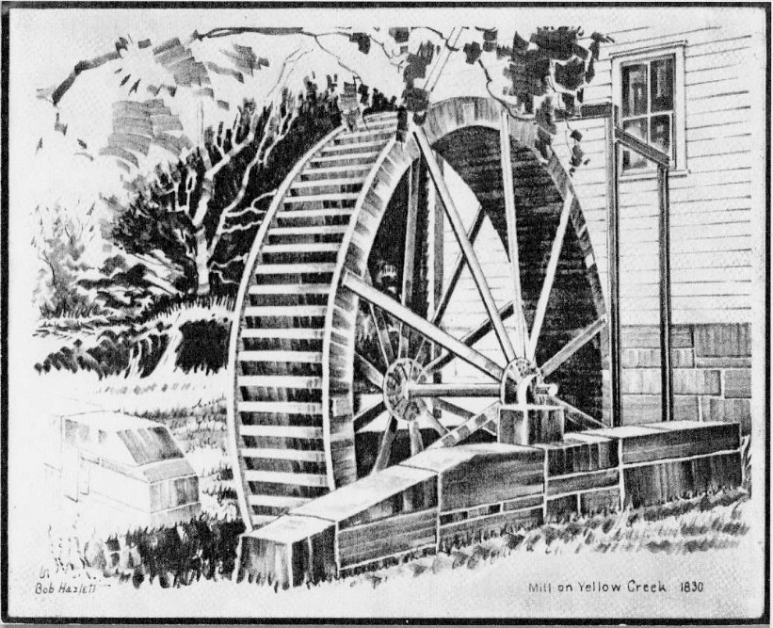

TABLE OF CONTENTS

Page #
I. INTRODUCTION 4
A. Designation Summary
B. Byway Route Map

II. BYWAY STRATEGIC PLAN 6
A. Vision, Mission and Beliefs
B. Accomplishments since last CMP
C. Goals, Objectives, and Action Plans

III. BYWAY ORGANIZATION 10
A. Structure and Organization
B. Committees, Representatives, Partners
C. Leaders’ Contact Information
D. Level of Participation in State/Regional Meetings and Trainings
E. Byway Leadership Succession Plan
F. Current and Future (5 Year) Funding Needs

IV. BYWAY CORRIDOR CONDITIONS 12
A. Road Conditions and Future Signage Needs
B. Primary and Secondary Intrinsic Quality/Resources
C. Changes in Intrinsic Quality/Resources since last CMP
D. Accessibility to Intrinsic Quality/Resources

V. VISITOR EXPERIENCE 16
A. Interpretation since Designation
B. Byway Story
C. Future Interpretation
D. Plans for Improving Visitor Experience
E. Preservation

VI. MARKETING AND PROMOTION 17
A. Current and Future Planned Marketing Activities
B. Recommended Products or Attachments for Media and Public Relations

VII. PUBLIC PARTICIPATION 19
A. Ongoing Communication and Cooperation with Community Partners
B. Public Meetings and Public Participation Opportunities
C. Steps Taken to Update Byway Mission and Vision
D. Narrative on Critical Issues and How They Will Be Addressed

VIII. APPENDIX 20
A. Seasonal Byway Photographs
B. Current Byway Brochure

I. INTRODUCTION AND MAP
A. Designation Summary
The Heritage Corridors of Bath is the story of Ohio's Western Reserve. In the early nineteenth century, settlers from Connecticut built homes and mills, and established farms and hamlets reminiscent of their New England origins. The byway passes through these hamlets, traverses streams, weaves along hillsides and offers vistas across farm land dotted with barns.
In 2000, the Bath Scenic Byway Task Force received designation from the Ohio Department of Transportation for 34.5 miles of scenic and historic byway along twelve roads, now known as the Heritage Corridors of Bath. A Corridor Management Plan was published in 2001. Subsequently new roads and sections of previously designated roads were added to the byway, resulting in a total of 39 miles of byway, that now includes fourteen roads. A Corridor Management Plan Addendum was adopted in 2007 and 2020.
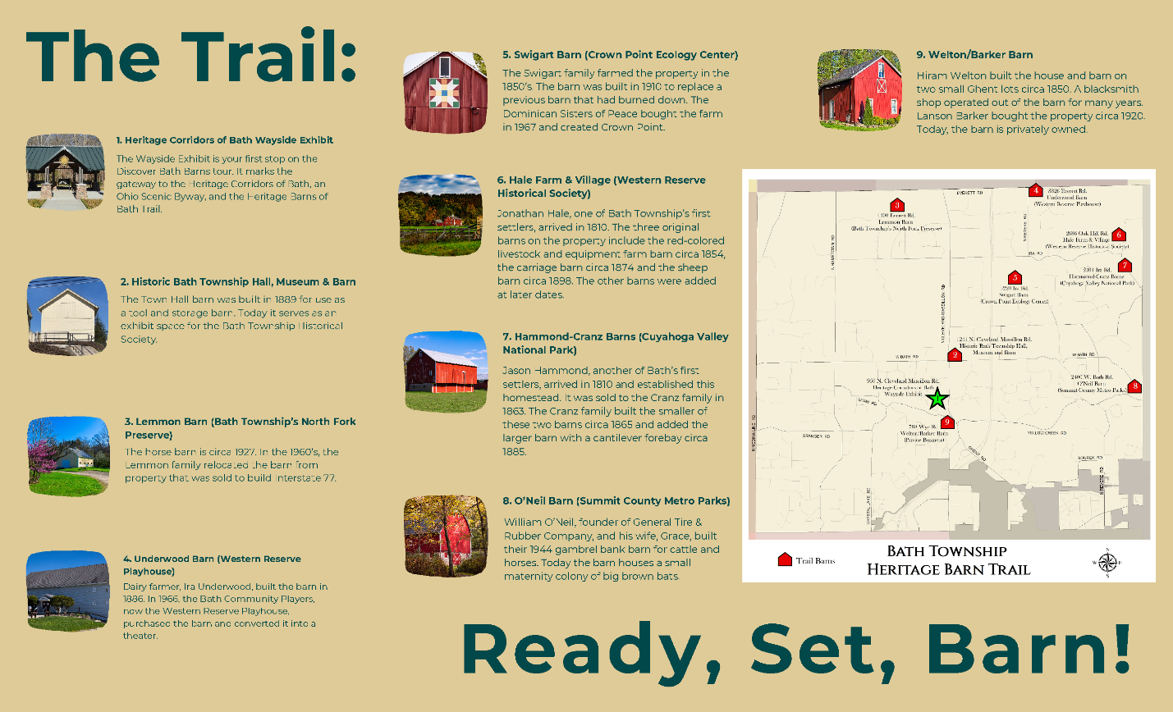

B. Byway Route Map
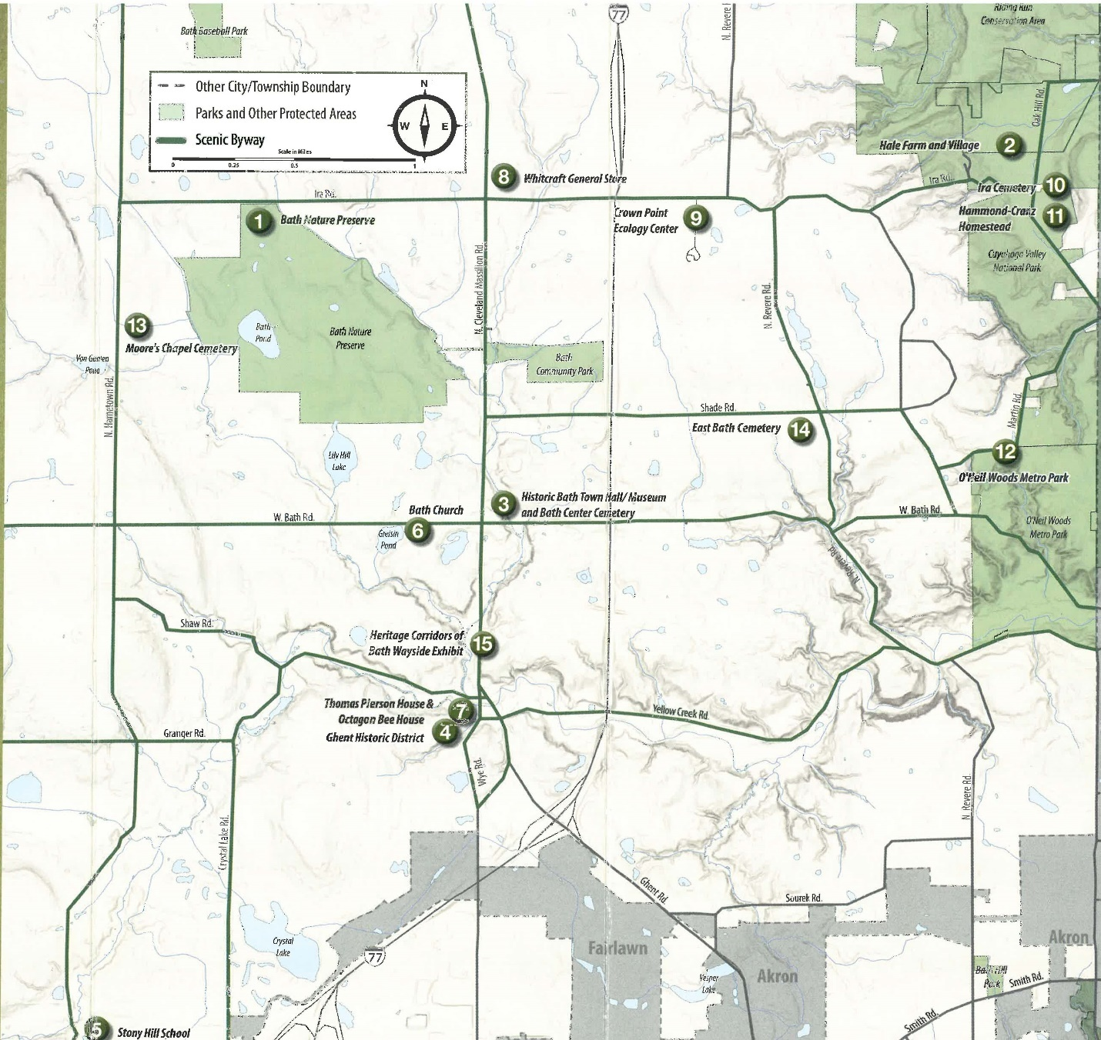
- Bath Nature Preserve 9. Crown Point Ecology Center
- Hale Farm and Village 10. Ira Cemetery
- Historic Bath Town Hall/Museum 11. Hammond-Cranz Homestead
Bath Center Cemetery 12. O’Neil Woods Metro Parks
- Ghent Historic District 13. Moore’s Chapel Cemetery
- Stony Hill School 14. East Bath Cemetery
- Bath Church 15. Heritage Corridors of Bath
- Thomas Pierson House and Wayside Exhibit
Octagon Bee House
- Whitcraft General Store
II. BYWAY STRATEGIC PLAN:
A. Vision and Mission
Vision:
The vision of the corridor is to protect the scenic rural views that have come to characterize Bath Township for future generations. And by also promoting and preserving our unique heritage as part of the Western Reserve, we wish to provide an enriching and pleasurable experience for those who travel the byway.
Mission:
1. To preserve and enhance the rural character, scenic beauty and historic legacy of the Heritage Corridors for future generations.
2. To enhance the appearance of the Cleveland-Massillon Road corridor and in particular, the character of the hamlets of Ghent, Bath Center and Hammond's Corners.
3. To guide future development so that it preserves natural areas, protects view sheds and riparian corridors and creates an architectural and landscape image in concert with the rural character of Bath.
4. To promote the preservation of rural landscape features on both public and private property.
5. To encourage the enjoyment and safe use of the corridors by pedestrians, bicyclists, equestrians and motorized travelers.
B. Accomplishments since last CMP
New accomplishments include:
- Addition of an observation deck overlooking Yellow Creek at the Wayside Exhibit-2025
- Heritage Barns of Bath Trail Information Board at the Wayside Exhibit-2025
- Heritage Barns of Bath Trail opened-2024
- Quilt competition winner is featured on the Western Reserve Playhouse-2024
- A Barn Quilt was donated by BTHS to the Bath Township Historic Tool Barn-2024
- Discover Bath Barns (Brochure)-2024
- North Fork Preserve of Bath opened with 2 miles of trails-2023
- Discover the Heritage Corridors of Bath, A self-guided tour (Brochure)-2023
Previous and ongoing accomplishments include:
- Installation of landscaping improvements at the Heritage Corridors of Bath Wayside Exhibit-2019-2025
- Installation of Ohio Historical Marker at Bath Center Cemetery and Historic Bath Town Hall-2019
- Bicentennial Celebration-2018
- Book-Century Homes of Bath-2018
- Summit County Astronomy Club Celestial Observatory-2017 ongoing
- Celestial Clock-2024
- Bath Art Fest-2017 ongoing
- New brochure of the Heritage Corridors of Bath’s historic, scenic and recreational sights-2016
- Heritage Corridors of Bath Wayside Exhibit with information boards featuring unique attributes of the Ohio Scenic Byway, the History of Bath, the Yellow Creek Watershed, and the Heritage Barns of Bath Trail-2016 ongoing
- Ohio Historical Marker at Ira Cemetery-2012
- Ohio Historical Marker at Moore’s Chapel Cemetery-2011
- Designation for the Ghent Historic District on the National Register of Historic Places-2010
- Annual Road Rally with the Bath Business Association-2008 ongoing
- Annual tour of Bath Township’s Heritage Corridors of Bath featuring century homes, three hamlets, historic schoolhouse, cemeteries-2006 ongoing
- Planting of trees at Hammond’s Corners reestablishing the leafy atmosphere of a crossroads hamlet-2004
- Design review of the Wye Road Bridge in Ghent with a heritage style that permits views of Yellow Creek-2003
- Installation of gateway signs placed at the three historic hamlets-2003
- An annual “Barn Social” to highlight different historic barns of Bath Township within the Heritage Corridors of Bath-2002 ongoing
- Replacement of the eroding hillside at Bath Elementary School with a barn stone retaining wall-2002
- Heritage Corridors of Bath-2002 ongoing
- Facilitated formation of the Bath Business Association-2002
- Brochure of the Heritage Corridors of Bath-2002
- Cemetery enhancements:
  - Bath Center Cemetery-2000, 2001, 2018
  - Moore’s Chapel-2002, 2003, 2006
  - Ira Cemetery-2006
  - Stony Hill Cemetery-2008
  - East Bath Cemetery-2008
- Ohio Historical Marker at Ghent Woolen Mill-2000

C. Goals and Objectives
Goal I: To preserve the scenic qualities
Objective | Action Plan
Pursue efforts to preserve green space through community education, township zoning, and appearance review boards. | • Apply for any applicable grants to preserve and create green space.  • Encourage the planting of native flowering shrubs and wildflowers along hillsides, stream banks, and woods within the view shed of the byway.  • Improve the landscaping at the Ira Road entrance to the Bath Nature Preserve.  • Work to connect walking trails to the Ohio and Erie Towpath Trail as well as connecting walking and biking paths through the township.
Improve the view shed of the byway by highlighting the natural qualities of it. | • Relocate overhead utility lines underground.  • Assess the landscaping at the confluence of Ghent Road and Cleveland-Massillon Road. Work to improve the view shed at this heavily traveled entrance to the byway.
Improve and maintain structures along the byway. | • Reassess each byway road for changes in corridor condition or view shed that have occurred since its original assessment. Revise goals and generate new projects for future improvement.  • Work with the Summit County Engineer's Office to replace aging bridges with open style architecture that improves the view shed of Yellow Creek and its tributaries. Explore other ways to promote views of streams.  • Encourage pedestrian scale lighting in the hamlets on Cleveland- Massillon Road.

Goal II: To preserve historic structures along the byway and area.
Objective | Action Plan
Work to place National Register of Historic Places plaques on registered structures. | • Work to achieve National Register of Historic Places designation for the Hammond's Corners Historic District.  • Explore ways to delineate the Ghent Historic District.  • Encourage home and business owners to pursue National Register of Historic Places designation.
Support members on the byway that promote and preserve historic structures. | • Acknowledge home and business owners who restore and preserve historic structures.  • Support byway farms, farm stands, and the Cuyahoga Valley National Park Countryside Conservancy.

Goal III: Partnerships and Community
Objective | Action Plan
Support and partner with local historic organizations, local governments, organizations, state government, and local businesses. | • Support local organizations that work to preserve historic structures and educate the community about Bath history, such as Bath Historical Society and Friends of the Regal Beagle.  • Meet regularly with the Summit County Engineer's Office to review Heritage Corridors of Bath goals and discuss future road projects.  • Collaborate with state byway organizations. Invite representatives from Ohio Department of Transportation to tour the byway and to share information and goals.  • Develop a dialogue with byway business owners and the Bath Business Association to share concerns and discuss common goals.  • Work with Ohio Department of Transportation on development of byway sign design.
Promote the byway and establish online presence as well as other social media platforms. | • Maintain a web site to educate visitors about the scenic byway, community events, and organizations.
Increase awareness of Bath Township’s history. | • Promote tours, barn social and Bath Township museum display, exhibits and books.
Develop the North Fork Preserve for community use. | • Build trails on the 78 acre property.  - Renovate the buildings for public meeting space.
Promote the preservation and enjoyment of barns in Bath Township. | - Manage a barn trail.  - Guide barn owners in preserving their barns.  - Encourage barn owners to enhance the exterior of their barns by adding barn art and barn quilts.  - Inform and educate the public about the community’s heritage represented by the barn.  - Ensure a historical record of Bath barns is kept.

III. BYWAY ORGANIZATION
A. Structure:
The Heritage Corridors of Bath committee exists to preserve the historic nature of Bath Township. The committee is organized by the township and made up of representatives and partners within the community.
B. Committees, Representatives, Partners
Committees
- Heritage Corridors of Bath
  - Discover Bath Barns
    - Information and Development
    - Preserve and Enhance
Representatives
- Jeff Andrew, David Axson, Barb Bailey, Pat Barb, Libby Bauman, Jackie Bennett, Kasha Brackett, Marc Braun, Laura Blanche, Sandra Brubaker, Becky Corbett, Kyle Craven, Lee Darst, Scott Eller, Dave Elzemeyer, Jenny Elzemeyer, Cindy Eitner, Sean Gaffney, Elaina Goodrich, Greg Gulish, Maureen Katanic, Clara Lamb, David Marchetta, Russel Marchetta, Phil McLean, James McClellan, Elizabeth McGrath, Dan Nelson, James Nelson, Kyle Passmore, Ellen Purduyn, John Sahl, Lisa Shaheen, Jan Shutte-Reed, Kathy Sidaway, Julie Slattery, Sandy Tomazic, Sharon Troike, Robert Wells, Torina White, Michele Whitehurst
Partners
- Bath Business Association
- Hale Farm and Village
- Bath Attractions Committee
- Bath Township Historical Society
- Summit County Astronomy Club
- Bath Art Fest
- The University of Akron Field Station
- Friends of the Regal Beagle
- Western Reserve Playhouse
- Crown Point Ecology Center
- Camp Christopher
- Bath Tour Committee
- Heritage Corridors of Bath Committee
- Akron Summit County Business Association
- Summit Historical Society

C. Byway Leader Contact Information
Primary Contact | Secondary Contact
Kasha Brackett  HCB Committee  Phone: 330-666-4007  Email: kbrackett@bathtownship.org | Elaina Goodrich  HCoB Committee  Phone: 330-666-4007  Email: egoodrich@bathtownship.org

D. Level of Participation in State/Regional Byway Meetings and Trainings
James McClellan regional byway meeting 2023
E. Byway Leadership Succession Plan
The committee is locally sponsored by Bath Township and will ensure the ongoing existence.
F. Current and Future Funding Needs
Bath Township funds the committee or requests grants and donations to carry out projects.

IV. BYWAY CORRIDOR CONDITIONS
The general condition of the roads is reviewed on an annual basis. Repairs and resurfacing are completed by the Summit County Engineer’s office.
A. Road Conditions and Future Signage Needs
The road signs were replaced in 2019, and the byway signs are to be reviewed.
B. List of Primary and Secondary Intrinsic Qualities/Resources
Primary/  Secondary Intrinsic Quality | Site and Location | Description
Historic | Jeremiah Lambert House and barn (c. 1838) | Built by Jeremiah and Lois Lambert, who operated a large farm on the property. Now on the National Register of Historic Places, it has been adapted for commercial use.
Historic | John Richard House (c.1838)  (41.187672, -81.636667) | Built by Lewis Lane, this early Greek Revival was later owned by John Richards. It has been adapted for commercial use.
Historic | Dustin Johnson House (c.1840s)  (41.188340, -81.636709) | John and Rebecca Rhodes built this house in the early 1840s. It sold to Elmus Jagger in the early 1850s; he operated a store in the home. Dustin Johnson owned the house in 1874. It is currently adapted for commercial use as a bank.
Historic | Pugh House (c.1830)  (41.189873, -81.636792) | George McCloud was identified as the earliest owner of this c. 1830 house, later owned by Roy and Ruth Pugh. Roy spent his career in education as a high school teacher and administrator, influencing generations of Bath scholars. The Pughs operated an antique store adjacent to their home.
Recreation  Nature  Scenic | Bath Nature Preserve (1998)  (41.180981, -81.650137) | This 411-acre preserve has 7.5 miles of hiking, biking and equestrian trails.
Nature  Historic | Crown Point Ecology Center (c.1850)  (41.188869, -81.619766) | Jacob Swigert built the house that is the center of the organic farm and living laboratory of ecology and sustainable land management. The 1910 historic barn is a prominent feature of the largest operating farm in the township.
Historic  Culture | Hale Farm and Village  (41.191830, -81.591970) | Hale Farm is a historic property of the Western Reserve Historical Society. Jonathan Hale arrived in Bath in 1810. The original brick home was built in 1825. It was listed on the National Register of Historic Places in 1973.
Nature  Culture | Heritage Corridors of Bath Wayside Exhibit  (41.162920, -81.636830) | A 2016 visitor center at the heart of the community. The exhibit houses informational panels on the history, watershed and sites of Bath Township.
Recreation  Nature | Bath Community Park  (41.178840, -81.636300) | Founded in 1968, the Bath Community Park is Bath’s oldest park. It hosts a variety of nature and recreational purposes, including several picnic areas, hiking trails, soccer fields, a football field, playground and more.
Nature  Recreation | University of Akron Field Station  (41.188930, -81.653340) | A living laboratory for the advancement of knowledge through ecological research, education.
Nature  Recreation | Summit County Astronomy Club Celestial Observatory (2018)  Bath Nature Preserve  (41*11’14.32”N,-81*39’.94”W) | Ten telescopes are available to view stars and planets on clear nights.
Historic | Whitcraft Store (1912 Rebuilt)  (41.189112, -81.636194) | Known as the “second largest general store in the state”, the Whitcraft store served Bath and the surrounding area in the late 1800s and early 1900s and was the social center of the area. The original building was built in the mid-1800s but was rebuilt after a fire in 1912.
Nature  Recreation | Cuyahoga Valley National Park  (41.281169, -81.567501) | The CVNP has 33,000 acres of which 800 are in Bath Township.
Historic | Rufus Randall house (c. 1860)  (41.189088, -81.634748) | Built in approximately 1860, Dr. Randall, a leader at the time, resided here. He was noted for finding successful new remedies used in his medicinal practice. He was also an advocate for equal rights and reform.
Historic | Bath Memorial Park  (41.168556, -81.636337) | In honor of the Bath citizens who served in the armed forces.
Historic  Culture | Historic Bath Township Hall and Museum (1905)  (41.169143, -81.636514) | The town hall was built in 1905 with a $25,000 bond. The building now hosts the Bath Township Historical Society Museum. The tool barn, built in 1889, was repurposed for exhibit space.
Historic | Bath Center Cemetery (c.1820)  (41.169242, -81.636443) | In 1834, the Hammond Family donated the land to the township. Within the cemetery was a Romanesque stone vault built in 1913 to store bodies during the winter when the ground was too frozen to dig graves.
Scenic  Culture | Chief Logan Statue  (41.179284, -81.635966) | A 20-foot-tall wooden sculpture located at Bath Community Park.
Historic | Bath Church (c.1820) (41.168149, -81.641583) | The original congregation of 1818 was a group of early settlers in the Western Reserve. They built a frame church that stood at Bath Center. The congregation moved to Ira Road c. 1842. It remained in Hammond’s Corners for nearly a century. In 1949 they moved the sanctuary to its current location on Bath Rd. in Bath Center.
Historic | The Ghent Woolen Mill (1832)  (41.158032, -81.638351) | The mill features an Ohio Historic Marker. The oldest known woolen mill still standing in Ohio. In its peak years, it processed 10,000 pounds of wool into finished cloth and yarn annually.
Historic | The Octagon Bee House  (41.157400, -81.637164) | Built by Thomas Pierson in 1859, the unique structure housed honey bees and is truly one-of-a-kind.
Historic | Thomas Pierson house (1837)  (41.157400, -81.637164) | Thomas Pierson was a grocer, a cooper, a bee keeper and a Justice of the Peace. In 1922, Dr. Robert Smith, a physician, owned the house. It has been adapted for commercial use.
Historic | Hiram Welton House and Barn (c.1850)  (41.157242, -81.637357) | Returning from Indiana Hiram and Hannah built this house in Ghent. In 1856 Robert Sloan operated a blacksmith shop from the barn.
Historic | Old Ghent Christian Church  (c. 1900)  (41.156549, -81.635803) | The original sanctuary was built c. 1900, then the belfry, vestibule and classrooms were added. The building has been adaptively used since the 1960s.
Historic | Yellow Creek Grist and Flour Mill  (41.160458, -81.649908) | Originally built in 1820, the mill burned down several times. The building was rebuilt in 1943 as Alderfer’s Mill.
Recreation  Nature  Scenic | O’Neil Woods (1972)  (41.173530, -81.594220) | A Summit Metro Park with 242 acres, developed in 1972. It is situated along Yellow Creak with a 1.8-mile walking trail. The O’Neil gambrel bank barn was built in 1944 for cattle and horses.
Historic  Recreation | Western Reserve Playhouse (1886)  (41.202340, -81.614110) | The early barn on this property was replaced by Ira and Louisa Underwood in 1886. In 1956 it was converted into a theater. Currently a non-profit theater group presents 8 plays annually.
Historic | Stony Hill Schoolhouse (1892)  (41.08228, -81.40159) | This one-room school is one of nine original school houses in the township and is now a museum.
Historic | Moore’s Chapel Cemetery  (41.181510, -81.665720) | Originally the Shaw Family Cemetery. Nathan Thorp, a Revolutionary War veteran, was buried here in 1840.
Historic | Ira Cemetery  (41.189400, -81.592350) | Recognized by the Ohio Historical Society, also known as the Hale, Hammond and Cranz Homestead Cemetery. Earliest burials include Mercy Piper Hale, 1829, wife of Jonathan Hale. Also buried here is Jason Hammond, 1830, Revolutionary War veteran.
Historic | Hammond-Cranz Homestead  (41.288380, -81.573530) | Originally built in 1818 by Jason Hammond and expanded in 1836 by his son, Lewis. William Cranz purchased the farm in 1863. Son, Eugene Cranz, farmed the land and promoted conservation. It is the oldest documented house in the township.
Historic | East Bath Cemetery  (41.175960, -81.610020) | The cemetery served families of German descent. A German Evangelical Church was once adjacent to the cemetery.
Recreation  Nature  Scenic | North Fork Preserve of Bath (2021) | The 78-acre preserve has 2.5 miles of hiking trails. It also has a historic home and 1927 barn.

Three Historic Hamlets of Bath:
- Bath Center
- Ghent
- Hammond’s Corner

C. Changes in Intrinsic Qualities/Resources since last CMP
Additions include:
A new observation deck at the Heritage Corridors of Bath Wayside Exhibit.
Changes include:
An addition of the Heritage Barns of Bath Trail including an information board at the Heritage Corridors of Bath Wayside Exhibit.
D. Accessibility to Intrinsic Quality/Resources: Pull-Offs, Parking, Rest Areas, Visitor Amenities, etc.
All resources, not including private homes and properties, are accessible by pull-offs or parking areas. The Heritage Corridors of Bath Wayside Exhibit Visitor Center is also accessible with a pull-off and a parking area.

V. VISITOR EXPERIENCE
A. Interpretation since Designation
The establishment of the scenic byway has allowed Bath Township to preserve its rural character and create a feeling of community pride as reflected in its historic roots. In 2018, the township celebrated a bicentennial, which amplified the values established in the Heritage Corridors of Bath.
B. Byway Story
The Heritage Corridors of Bath is the story of Ohio's Western Reserve. In the early nineteenth century, settlers from Connecticut built homes and mills, and established farms and hamlets reminiscent of their New England origins. The byway passes through these hamlets, traverses streams, weaves along hillsides and offers vistas across farm land dotted with barns.
In 2000, the Bath Scenic Byway Task Force received designation from the Ohio Department of Transportation for 34.5 miles of scenic and historic byway along twelve roads, now known as the Heritage Corridors of Bath. Subsequently new roads and sections of previously designated roads were added to the byway, resulting in a total of 39 miles of byway, that now includes fourteen roads.
The newly designated Heritage Barns of Bath Trail identifies a 19-mile, nine stop, self-paced, circular trail which connects the nineteenth century rural heritage represented by numerous barns, with hamlets of Ghent, Hammond Corners and Bath Center, our parks, such as the North Fork Preserve, the Bath Nature Preserve, the Cuyahoga Valley National Park, Summit Metro Parks and our community groups like the Western Reserve Playhouse, Crown Point Ecology Center, and Hale Farm and Village. While the many heritage barns are featured, the traveler will be able to see several century homes, business structures and visit cemeteries while winding through areas of natural and scenic beauty.
C. Future Interpretation
Review of the Byway signs to identify the 39 miles of the Heritage Corridors of Bath.
D. Plans for Improving Visitor Experience
The Heritage Corridors of Bath Wayside Exhibit is situated along the main thoroughfare in Bath Township, north of the Ghent Historic District on Cleveland-Massillon Road. The site offers visitors an opportunity to learn about the byway, the watershed, and township history. Bath Township continues to improve the 7-acre parcel known as the Wayside Exhibit to attract visitors to the area.
E. Preservation
- Historic Town Hall and Museum will feature an exhibit called the Mills and Industries of Early Bath in 2025. This is only one example of the annual exhibits showcased to highlight the history in the township.
- An annual tour is planned for 2025. This year Pleasant Valley is featured on the Founder’s Tour.
- In the planning stage is renovation of the 1927 barn into public meeting space on the North Fork Preserve of Bath and use of the property for passive recreation.
- A summer speaker series informs the public about preservation of barns.
VI. MARKETING AND PROMOTION
A. Current and Future Planned Marketing Activities
- Notable annual events which gain attraction to the byway:
  - Annual exhibit highlighting the township’s history-Bath Township Museum.
  - Chillin’ on the Hill – Bath Nature Preserve
  - Spring into Nature-Bath Nature Preserve
  - Fall into Nature – Bath Nature Preserve
  - Memorial Day Observance – Veteran’s Memorial
  - Barn Social – New location each year featuring a historic barn
  - Run to the Sun – Bath Community Park and Bath Nature Preserve
  - Suns Out, Funs Out-Bath Community Park during the summer solstice
  - Bath Art Fest-Bath Community Park
  - Barn Burner 5K-North Fork Preserve
  - Historical Tour- New location each year featuring a historic area
  - Road Rally-Bath Township
  - Civil War –Hale Farm and Village
  - Made in Ohio – Hale Farm and Village
  - Wye Road Bridge Lighting-Ghent Hamlet
B. Recommended Products or Attachments for Media and Public Relations
i. Short description of byway for use in publications.
The Heritage Corridors of Bath is the story of Ohio's Western Reserve. Early nineteenth century settlers from Connecticut built homes and mills and established farms and hamlets reminiscent of their New England origins. The byway passes through these hamlets, traverses streams, weaves along hillsides and offers vistas across farm land dotted with barns. All these qualities are nestled in the Cuyahoga Valley region of Ohio, highlighting some of the most beautiful qualities of the state.
ii. Seasonal digital photographs (at least 300 dpi).
See appendix.
iii. Brief description of the top 5-10 unique/authentic attractions on the byway.
# | Name | Description | GIS
1 | Bath Nature Preserve | The 411-acre Bath Nature Preserve supports a diverse community of plants, animals, bugs, bacteria, fish, reptiles, and amphibians. The vibrant ponds facilitate their habitat as a crucial watershed for the Cuyahoga region. | 41.181045, -81.650122
2 | Bath Center Cemetery | Bath Center Cemetery was acquired in 1817 for the intended use as a burial ground and meeting house. This provided a public and religious place for residents to bury their loved ones. | 41.168724, -81.636575
3 | Ghent Woolen Mill | This was one of thirteen mills built in the Yellow Creek Valley to take advantage of water as an energy resource. It was built in 1832 and is the oldest standing mill in all of Ohio, retaining much of its original architectural features. | 41.158041, -81.638279
4 | Historic Bath Township Hall and Museum | The Bath Township Museum promotes community activities and interest in Bath's heritage through publications, exhibits/displays of the collection and programs. Furthermore, it maintains and preserves historical materials for education and research. | 41.169157, -81.636472
5 | Hale Farm and Village | This is a 90-acre living history museum on historic property, which is a part of the Western Reserve Historical Society. It resides within the boundaries of Cuyahoga Valley National Park. There are 34 historical structures on the property. The Hale family farm demonstrates entrepreneurship and prosperity within Bath Township. It offers self-guided tours, featuring farm animals, a heritage garden, farming, and early American craft and trade demonstrations. | 41.193696, -81.592389
6 | Octagon Bee House | Built by Thomas Pierson in 1859, the unique structure housed honey bees and is truly one-of-a-kind. | 41.157494, -81.637485

iv. Provide website/URL (if available) and local website/URL that manages byway.
http://www.bathtownship.org/
https://www.allthingsbath.com/heritage-corridors
v. Marketing contact information:
Heritage Corridors of Bath
3864 W. Bath Road
Akron, Ohio 44333

VII. PUBLIC PARTICIPATION
A. Ongoing Communication and Cooperation with Community Partners
Partnerships are vital to the implementation of the Heritage Corridors of Bath mission. Within Bath Township, the Bath Business Association and the Bath Township Historical Society pursue goals in tandem to emphasize the mission of the Heritage Corridors of Bath.
Originally an outgrowth of a Heritage Corridors of Bath Committee focus group, the Bath Business Association has emerged as a respected and influential voice in the community. With their many contributions and sponsored events, they are a model of responsible stewardship in the hamlets. The Annual Wye Road Bridge Lighting Festival has become a popular venue for residents to celebrate the holiday season. And throughout the year, hamlet businesses take pride in their seasonal landscaping and decorations.
The Bath Township Historical Society manages the Bath Museum at the Historic Town Hall in Bath Center. Bath Township's Tour Committee hosts walking and bus tours of the township. The Discover Bath Barns Committee has contributed a monthly installment, The Barns of Bath, to the Bath Country Journal. The well-researched articles and accompanying photographs of the township's early barns and settlers have stimulated interest and pride in Bath's heritage. In 2023, a 52 page booklet Discover the Heritage Corridor’s of Bath, a self guided tour was published and in 2024, a 12 page booklet Discover Bath Barns was printed and are available at the Museum.
B. Public Meeting and Public Participation Opportunities
The Heritage Corridors of Bath meets on the second Wednesday in February, April, June, August and October. A Barn Social is held in place of the September meeting and is attended by 60-100 people each year. All meetings are publicized and open to the public.
C. Steps Taken to Update Byway Mission and Vision
The township’s Heritage Corridors of Bath spent considerable time reviewing their vision and mission when planning for the Heritage Barns of Bath Trail, which was completed in 2024, and the America 250 Celebration in 2026.
D. Narrative on Critical Issues and How They Will Be Addressed
There are no critical issues.

VIII. APPENDIX
- Seasonal Byway Photos
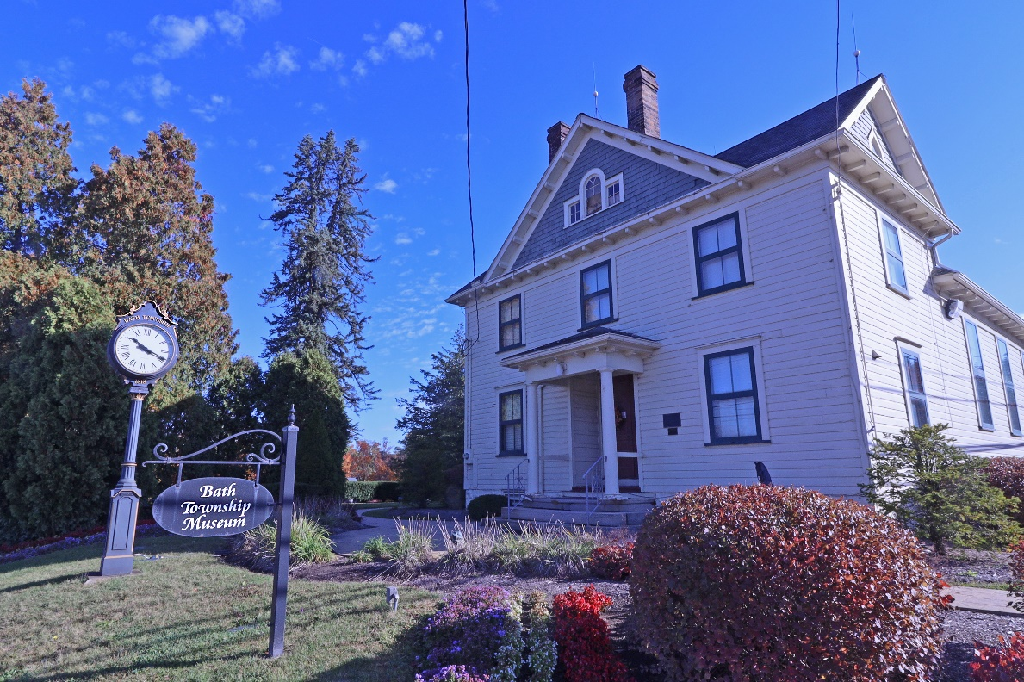
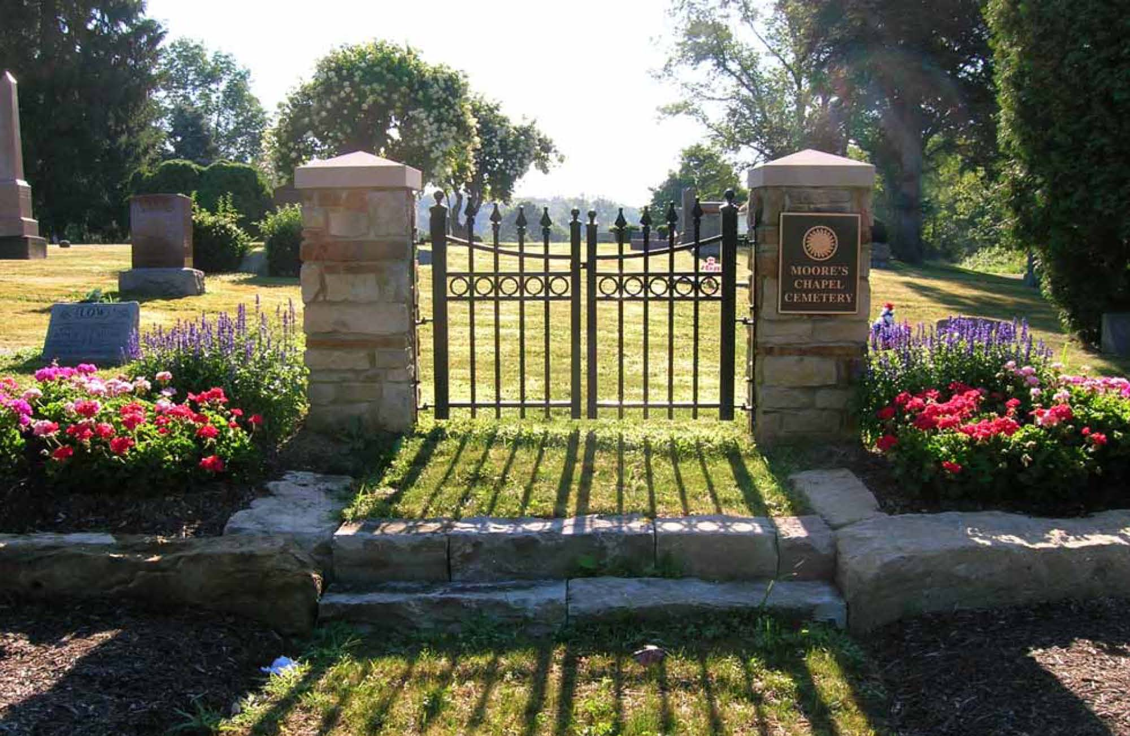

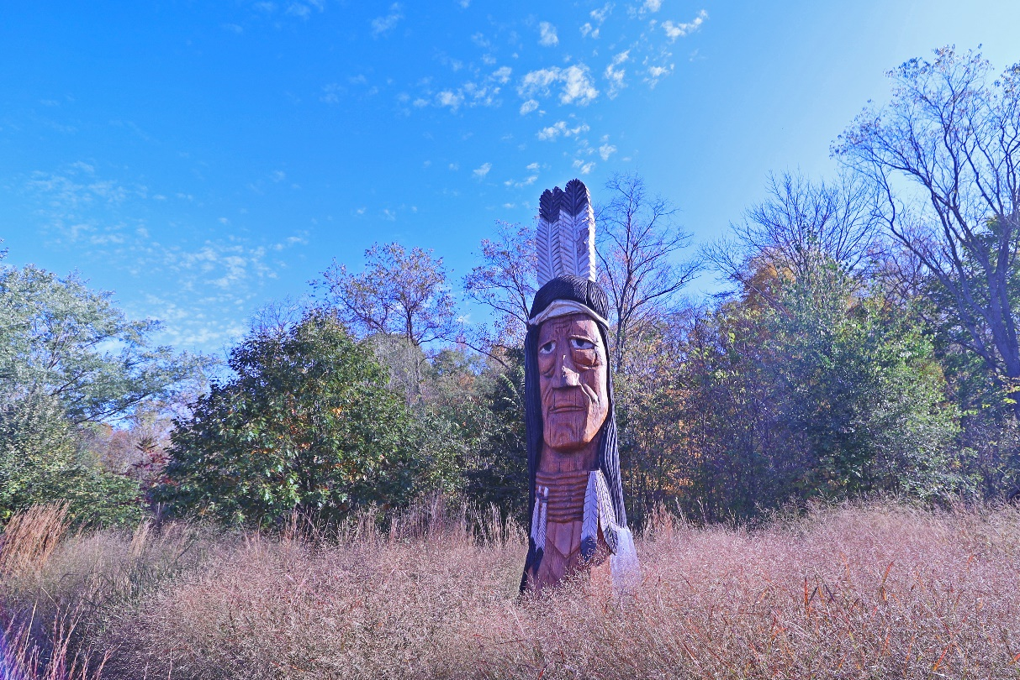
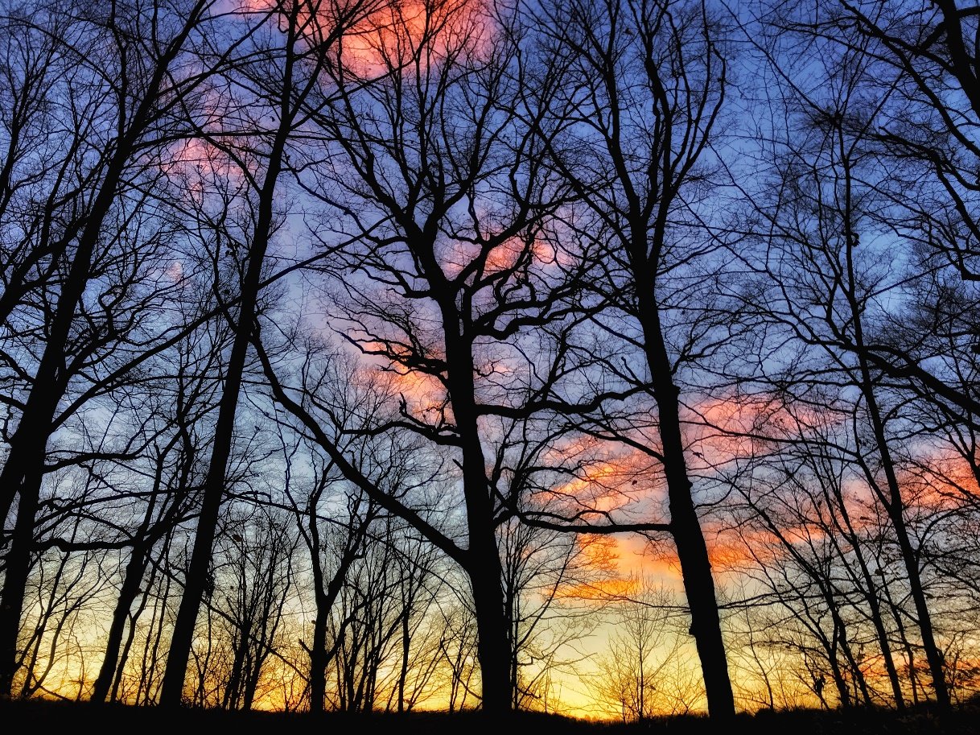

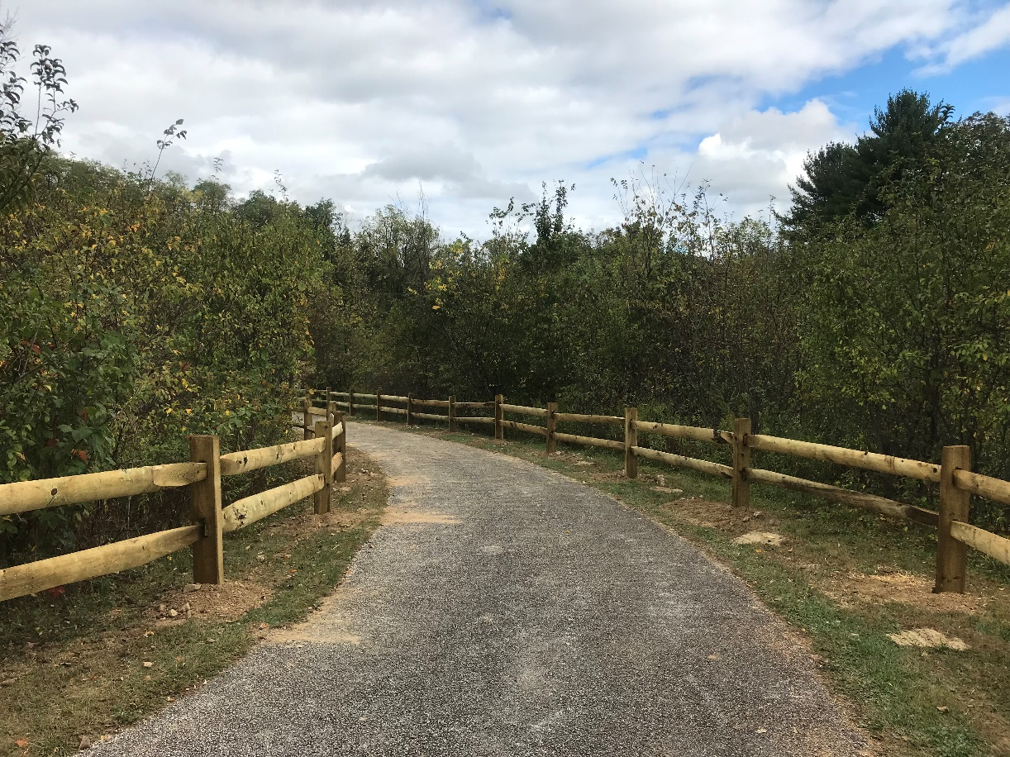
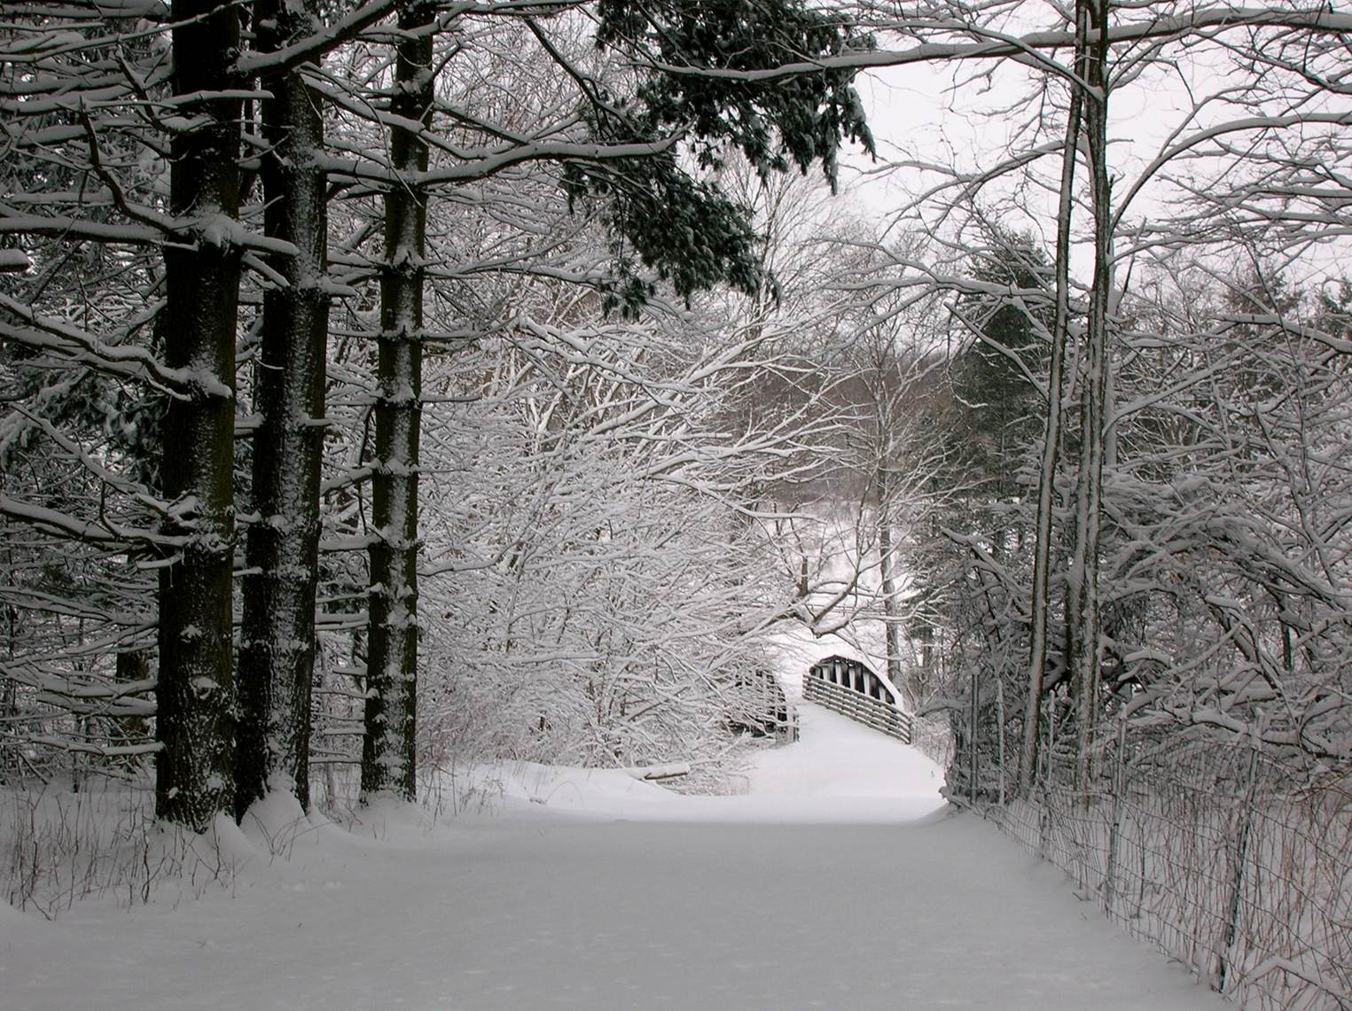

- Current Byway Brochure
